Velyx – Architecture, System Design & Data Flows
Architecture readout for the Velyx continuous reliability guidance engine (MVP-focused, enterprise-ready, lean).

1. Purpose
This document describes the target architecture and system design for Velyx, including key components, integration points, data models, and end-to-end data flows for the MVP. Velyx reconciles inferred intent, infrastructure posture (from IaC), and runtime behaviour summaries to generate continuous reliability recommendations.

2. Architecture Views
The following diagram set provides three complementary views of the Velyx prototype architecture (logical components, integration points, and flow orientation).
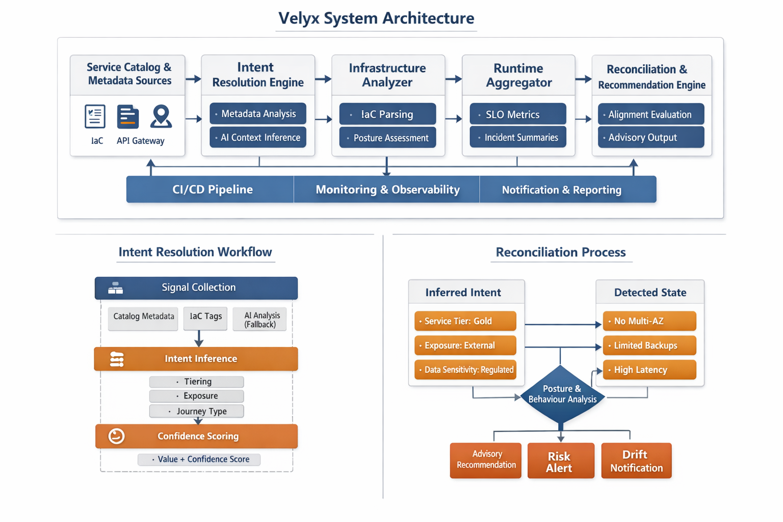
Figure 1: Velyx architecture views (prototype).

3. Logical Architecture (MVP)
Velyx is composed of five core modules:
- Intent Resolver – infers service intent from structured metadata (with confidence and evidence).
- Terraform Analyzer – parses Terraform plan JSON to derive infrastructure posture.
- Runtime Summary Ingestor – consumes summarized signals (SLO status, error budget burn, incident trend).
- Reconciliation Engine – compares required posture vs detected posture across infrastructure and runtime.
- Recommendation Generator – emits actionable recommendations, drift alerts, and a structured report.
The MVP emphasizes advisory outputs and low adoption friction. Velyx does not perform raw telemetry analytics; it integrates above existing observability platforms via summary interfaces.

4. Deployment View (Lean Enterprise)
Recommended MVP deployment options:
- CLI-first: run as a CI job step and as a scheduled batch job (nightly drift scan).
- Containerized service: a small API + worker model for teams that prefer always-on integration.
- Storage: lightweight object store / database for snapshots (IntentSnapshot, InfraPosture, BehaviourSnapshot, Findings).
For demo packaging, Velyx can run fully in Docker with local storage. For enterprise, snapshots can be stored in a managed database and reports forwarded to dashboards or collaboration tools.

5. Interfaces and Integration Points
Inputs (MVP):
- Service metadata: service catalog export (JSON) or API (e.g., Backstage-like).
- Terraform plan JSON: produced in CI from terraform plan/show.
- Runtime summaries: SLO compliance, error budget burn, incident metadata (exported via API or periodic file).
Outputs (MVP):
- Structured report.json (findings, posture comparison, confidence, evidence).
- Human-readable summary (Markdown/text) for CI logs and pull request comments.
- Optional notifications (Slack/email) for RISK/DRIFT.

6. Core Data Models (MVP)
Velyx persists versioned snapshots for traceability and drift detection:
- IntentSnapshot: service_id, env, intent_fields{value, confidence, evidence}, timestamp, snapshot_version.
- InfraPosture: service_id, env, posture_fields (ha, scaling, backups, redundancy), timestamp, source_plan_ref.
- BehaviourSnapshot: service_id, env, slo_summary, error_budget_burn, incident_trend, traffic_trend, timestamp.
- Finding: type (infra/runtime), severity (PASS/ADVISORY/RISK/DRIFT), expectation, observed, recommendation, evidence.

7. Data Flows

7.1 CI/CD Flow (Infrastructure Reconciliation)
Trigger: Pull request or pipeline run that changes infrastructure code. Goal: Ensure infrastructure posture remains aligned with inferred intent.
- CI generates terraform plan JSON.
- Velyx Intent Resolver pulls service metadata and computes IntentSnapshot (with confidence/evidence).
- Terraform Analyzer derives InfraPosture from plan JSON.
- Reconciliation Engine compares IntentSnapshot vs InfraPosture and creates Findings.
- Recommendation Generator outputs report.json + CI-friendly summary (non-blocking by default).

7.2 Scheduled Drift Scan (Infrastructure Drift)
Trigger: Nightly or weekly scheduled run. Goal: detect drift in posture due to incremental infra changes and evolving intent signals.
- Refresh IntentSnapshot from latest metadata sources.
- Analyze most recent Terraform plan/state snapshot (or latest plan artifact).
- Compute deltas against previous snapshots (Intent drift, Infra drift).
- Emit DRIFT findings and notify owners if thresholds exceeded.

7.3 Runtime Reconciliation Flow
Trigger: periodic ingestion (e.g., hourly/daily) of summarized runtime signals. Goal: determine if runtime behaviour matches intent expectations.
- Runtime Summary Ingestor fetches SLO compliance and error budget burn summaries.
- BehaviourSnapshot is created and stored.
- Reconciliation Engine compares IntentSnapshot vs BehaviourSnapshot.
- Findings are emitted for operational drift (e.g., sustained budget burn for high-tier services).
- Recommendation Generator outputs guidance and optional notifications.

8. Key Design Decisions
- Advisory-first: Velyx produces guidance; enforcement thresholds remain configurable by teams.
- Metadata-driven intent: structured sources are preferred; AI supplements only when needed and always with confidence.
- No raw telemetry processing in MVP: Velyx consumes summaries to avoid becoming an observability platform.
- Versioned snapshots: every run produces traceable snapshots enabling drift detection and auditability.

9. Appendix – Output Artifacts (Examples)
Typical artifacts produced per run:
- out/intent.json
- out/infra_posture.json
- out/behaviour_snapshot.json (if runtime enabled)
- out/report.json
- out/summary.md

